We would like to send a great big 'Thank you' to the previous Playground Committee who helped us purchase some new trees for our school yard. In addition to helping make the playground even more beautiful, children will be able to enjoy more shade during the warmer days.

The Townsview Home and School Association is looking for new volunteers to join our team. This is a wonderful opportunity to meet new people, help organize exciting events and make a difference in your school community. You can volunteer as little or as much time as you wish, as every little bit helps make a big difference.

Email: homeschooltownsview@gmail.com
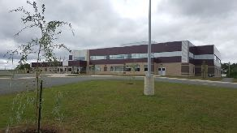
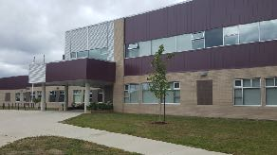
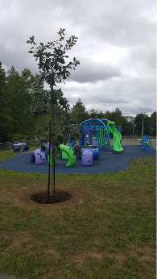
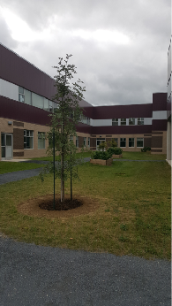
Facebook page: https://www.facebook.com/townsviewhomeandschool/#

Meeting

Our first meeting will be held at 7pm on Thursday, September 19, 2017
in the boardroom, next to the library.

The Home and School

Committee would like to wish an awesome year to all the staff and students. Hope everyone can have a great year!

